Brad Osborn

Data Analyst Nanodegree

Project 1

5-11-19

Analyzing Weather Trends in Seattle Against Nation Averages

1. Process: In order to create my observations, I had to first extract the data to csv using the provided SQL tool. The queries used were SELECT * FROM global_data; and SELECT * FROM city_data WHERE city = 'Seattle'; and then selecting download to csv. Once in csv I combined the two data sets and saved as an Excel workbook. I then realized that the national data had more yearly recordings than those for Seattle so I only included years that were recorded by both data sets. I then applied a 7-year moving average to the available years using the Excel function =AVERAGE(range). After that I selected the two moving year average sets and inserted them into an Excel line chart. The only thing remaining was to beautify my chart. My focus for that was to make sure the values are surmisable without including all of the individual values to reduce clutter. I showed the years on the bottom axis and did the tick marks in 5-year increments so that it was not too cluttered while still easy to view what year is in question. Finally, I included a title, axis titles, and a legend so that the viewers are easily able to understand what information they are meant to derive from my chart.
2. 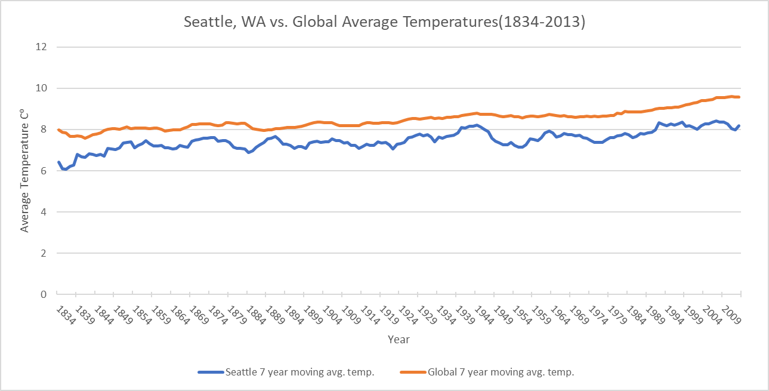
3. Key observations made:

At no point in the recorded data did Seattle have a higher 7-year moving average temperature than the global average(this was also true for yearly averages rather than moving average).

While Seattle had a lower average temperature than the global averages the positive trend was consistent in both data sets. One could use this information to say that the world is getting hotter over time.

The 7-year global moving average was a much smoother trend than the one for Seattle. Seattle was very fluctuate seemingly switching between a positive to negative trend from point to point. This could be because the global average is likely an average of averages already.

There were a few missing values in the Seattle data set. This doesn’t affect the formulas used, though, it is just curious as to why those values were missing. It also makes me question the global averages if the Seattle temperatures were not included.

It makes sense that Seattle has lower average temperatures than the global averages due to the city’s distance from the equator.